How did you find out about this vacancy?
Disability Discrimination Act

The Disability Discrimination Act protects people with disabilities from unlawful discrimination. It defines disability as a “physical or mental impairment which has a substantial and long term adverse effect on the ability to carry out normal day-to-day activities”.
Do you consider yourself to have a disability? |  |  |  |  |  | Yes |  | ☐ |  |  | No |  | ☐ | Prefer not to say |  |  | ☐
How would you describe your ethnic origin?

Asian or Asian British – Bangladeshi |  |  |  | ☐ |  | Mixed – White & Black African |  |  |  |  |  |  |  |  |  | ☐
Asian or Asian British – Indian |  |  |  | ☐ |  | Mixed – White & Asian |  |  |  |  |  |  |  |  |  | ☐
Asian or Asian British – Pakistani |  |  |  | ☐ |  | Mixed- White & Black Caribbean |  |  |  |  |  |  |  |  |  | ☐
Other Asian background |  |  |  | ☐ |  | White – British |  |  |  |  |  |  |  |  |  | ☐
Black or Black British - African |  |  |  | ☐ |  | White - Irish |  |  |  |  |  |  |  |  |  | ☐
Black or Black British - Caribbean |  |  |  | ☐ |  | Traveller |  |  |  |  |  |  |  |  |  | ☐
Other Black background |  |  |  | ☐ |  | Other white background |  |  |  |  |  |  |  |  |  | ☐
Chinese |  |  |  | ☐ |  | Prefer not to say |  |  |  |  |  |  |  |  |  | ☐
If other please specify:
How would you describe your gender? |  |  | Male |  |  |  | ☐ |  | Female |  |  | ☐ |  |  | Prefer not to say |  | ☐
How would describe your sexuality? |  | Heterosexual |  |  |  |  | ☐ |  |  | Gay |  | ☐ |  |  | Lesbian |  | ☐
 |  | Bisexual |  |  |  |  | ☐ |  |  | Other |  | ☐ |  |  | Prefer not to say |  | ☐
What age group are you in? | 16-25 |  |  |  |  |  | ☐ |  |  | 26-35 |  | ☐ |  |  | 36-45 |  | ☐
 | 46-55 |  |  |  |  |  | ☐ |  |  | 56-65 |  | ☐ |  |  | Over 65 |  | ☐
 | Prefer not to say |  |  |  |  |  | ☐
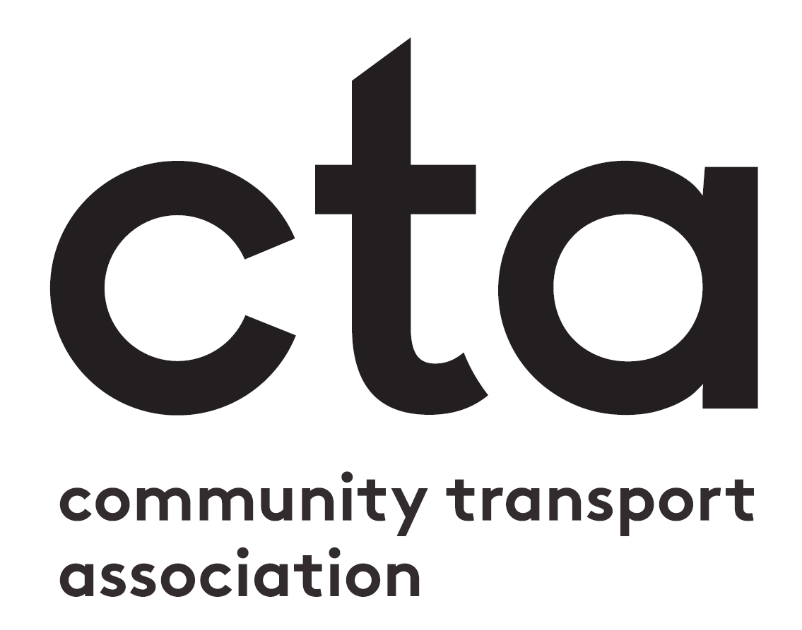

Community Transport Association
Equalities Monitoring Form

