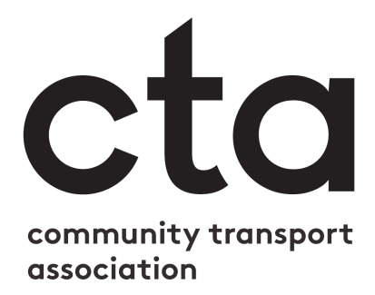

Community Transport Association
Trustee Application Form

Post Applied For | Trustee
Closing Date | Wednesday 25 July 2018
Completion instructions:

Please type in the shaded interactive boxes below. These will expand to allow you to enter as much text as necessary.
Return instructions:

Please submit this form, with your CV and equalities monitoring form no later than 12:00 on 25 July 2018 by email to maxine@ctauk.org

It is the applicant’s responsibility to ensure that applications are received by the deadline shown. Postal applications will not be accepted.

Personal & contact details
Last name: | Telephone & email contact details:  Home:  Mobile:  Work:  E-mail:
First name:
Address:

Which CTA membership organisation(s) are you currently connected to?

What is your current role within the organisation(s)?

Supporting statement
Please use the space to supply a personal statement to support your application. You should clearly set out how you meet the attributes for fulfilling the responsibilities of a trustee shown in the role description in the recruitment pack. It is vital that all applicants complete this section fully.

[Continue on separate sheet if necessary]
Election address
In the event that a ballot is organised, a short election address from each candidate will be issued to CTA members. This is your chance to communicate directly with members who will be voting in the election about what you will bring to the role and why they should choose you. In this space please write your election address. It should be no more than 200 words.

References
Please give details of two individuals, not related to you, who will provide relevant references. One of these should be from the main CTA membership organisation you are connected with that you indicated on the first page of the application form. Both should be people who are able to comment authoritatively on your ability to perform duties of the role of CTA Trustee.
Name: | Name:
How is the referee known to you? | How is the referee known to you?
Address: | Address:
Tel No: | Tel No:
Email: | Email:

Declaration & Data Protection
In submitting this form by email you agree to the following terms:

In accordance with the General Data Protection Regulation, I understand that the information I have provided on this form will be stored by the Community Transport Association manually or electronically as per the CTA’s Privacy Policy, and I have the right to see a copy of the information held on me by appointment.

I have read the information pack and can confirm that I am eligible to be considered for appointment to this body. To the best of my knowledge the information that I have provided on this form is correct. I understand that providing false or misleading information, or deliberately omitting relevant information, will disqualify me from appointment or render me liable for removal from office within the agreed procedures.

