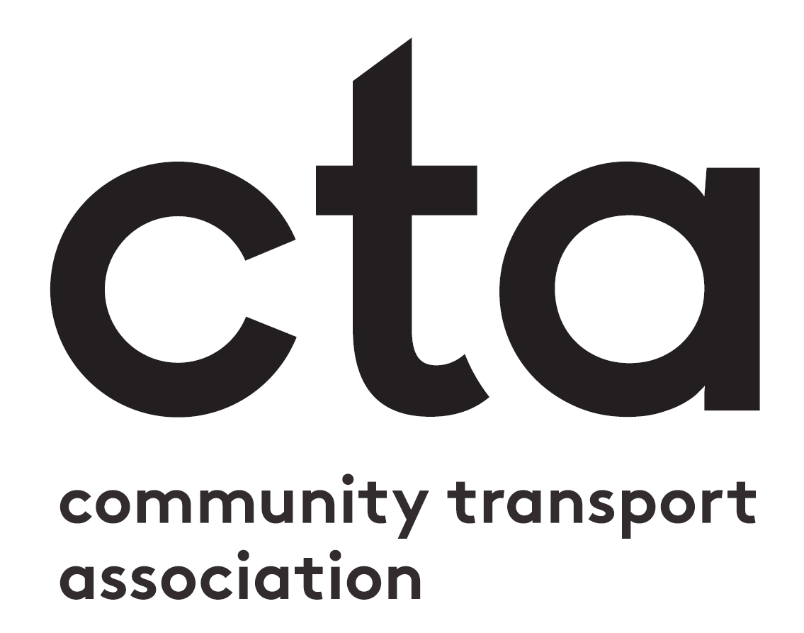

CTA’s Scotland Conference
Bring a trustee discount form

To book your discounted place for trustees, please fill in this booking form and email it to bookings@ctauk.org. If you are booking for more than one participant, please fill out a booking form per person. Please note this discount is only valid if you have already purchased at least one full priced ticket.
Price: £40
Participant name:
Participant job title:
Organisation:
CTA Membership Number
(if applicable)
Email address:
Dietary or accessibility requirements:

Payment
Please select a method of payment:
If you wish to pay by credit or debit card, please submit your form and contact the CTA central office on 0161 351 1475.

☐
☐
Please invoice my organisation
Pay by credit/debit card
Community Transport Association UK is a charitable company limited by guarantee. Registered in Cardiff no. 1985361 Registered office: 12 Hilton Street M1 1JF. Registered as a charity in England and Wales no. 1002222. Charity Registered in Scotland No. SC038518.

