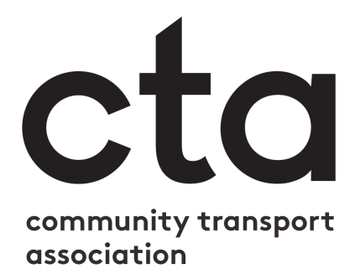

You can replace this box with your own logo, or delete it.

Information for passengers of community transport services
As you’ll know, coronavirus has brought about many changes for our organisation and the way we deliver services in our community. We’re very happy to welcome you back and, to help ensure the safety of both you and our team, we’ve put in place a number of measures which are designed to keep us all as safe as possible.

To protect your safety, we have:
- Conducted a risk assessment to help us identify the hazards created by the COVID-19 virus, and how we will work to manage and control these ✓
- Cleaned our vehicles to a high standard, including seats, handles and doors ✓
- Made sure our drivers and passenger assistants are symptom-free, wearing appropriate protective equipment, and are cleaning their hands regularly ✓
- Planned the seating in our vehicles to help you maintain the recommended distance from others ✓
- Where possible, added a shield to our driver’s area to create additional separation ✓
- Begun using safer payment systems, including payment by phone, contactless card reader, and cash boxes ✓
- Trained our drivers and passenger assistants in the recommended cleaning and hygiene standards ✓
- Arranged to keep our vehicles well ventilated ✓
- Undertaken that we will not carry more passengers than is safe on any one journey ✓

We ask that you:
- Consider other alternatives to access services e.g. delivery options, before you make a booking. Please note: Government guidance that only ‘essential journeys’ should be made now only applies to car-sharing (except Wales were only essential journeys are permitted regardless of vehicle). But it still advises that ‘public transport’ is to be avoided if possible, and that some people, including those aged 70 or over, should continue to take particular care to minimise contact with others outside their household, and that people who are vulnerable on health grounds should continue ‘shielding’.
- Do not attempt to travel if you or anyone in your household has any symptoms of COVID-19, including a higher than normal temperature, new continuous cough, and/or loss of taste/smell
- Wear a face covering unless you are medically unable to
- Use the provided hand sanitiser when boarding the vehicle
- Follow the driver’s/passenger assistant’s advice on when to get on and off the vehicle, and where to sit to keep the recommended safe distance from others
- Let us know if you need any assistance with your journey when you book.
- If you need additional support, including getting on/off the vehicle, fastening your seatbelt, or carrying shopping, we are happy to transport someone else from your household to give you this assistance if they are also symptom free.
- To minimise contact we may be able to convey you to and from the vehicle using a wheelchair
- Maintain as much distance as possible from others while using the service
- Understand that we may need to ask about your health and situation

