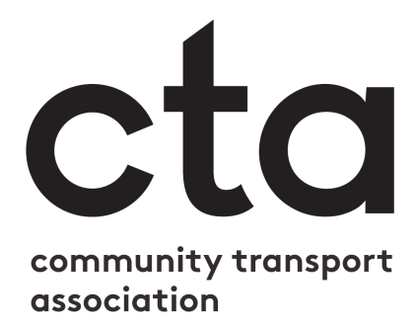

You can replace this box with your own logo, or delete it.

Start of shift / daily COVID-19 checklist for drivers
Coronavirus has brought about many changes for the community transport sector. As a driver for a community transport provider, it is essential that you read, understand and agree to the following. Please read this document and indicate that you understand and agree with everything stated, by checking the relevant boxes and signing your name at the bottom.
Neither I nor anyone in my household is exhibiting symptoms of COVID-19 (including a higher than normal temperature, new continuous cough, and/or loss of taste/smell)
I have checked with the Transport Manager/Office Manager if any updated guidance or risk assessments have been issued since my last shift
I have received training in any new practice or guidance implemented since my last shift
I have enough PPE on board the vehicle for the scheduled run/services
I have removed seats/cordoned off seats as is required to ensure proper social distancing for this shift
I have washed and sanitised my hands and ensured sufficient hand sanitiser is on board for myself and passengers
I have cleaned my vehicle before the start of the shift to the standard set out in the risk assessment/staff handbook/passenger transport plan/standard operating principles
I have sanitised all door and grab handles, seats and seat belts before starting out and will repeat between each passenger journey
I have cleaned and sanitised the ticket machine and card reader before starting and will repeat between each use

Please remember on this shift to:
- Check if the passenger, or anyone else in their household, has any COVID-19 symptoms before they come out to or board the vehicle
- For passengers who are symptom free and can travel, follow the risk assessment and passenger transport plan to safely get the passenger on board and to their destination
- Keep the vehicle well ventilated
- Make sure all relevant surfaces are cleaned when a passenger leaves the vehicle (door and grab handles, seats and seat belts)
- Sanitise the card reader and ticket machine after each use (unless contactless)
- Make sure any wet floors or surfaces are dry before passengers board
- Follow the risk assessment and passenger transport plans in place for collecting passengers, including maintaining the recommended distance where possible, wearing PPE, etc.
- Follow the PPE guidelines from your training when assisting passengers on and off the vehicle, securing seatbelts or wheelchair restraints, or moving bags and mobility aids

Driver Name:
Driver Signature:
Date

