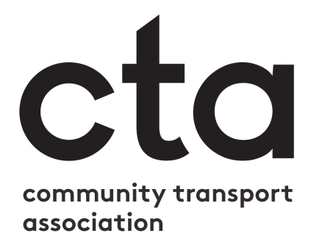

You can replace this box with your own logo, or delete it.

Guidance for Community Transport Drivers
Coronavirus has brought about many changes for the community transport sector. As a driver for a community transport provider, it is essential that you read, understand and agree to the following.
Please read this document and indicate that you understand and agree with everything stated by checking the relevant boxes and signing your name at the bottom.

General information

I have:
Read my organisation’s risk assessment and understand my duties outlined there
Let the Transport Manager/Office Manager [delete as appropriate] know about any underlying health conditions that may place me at risk
Received training on how to maintain the recommended distance from passengers and colleagues where possible
Received training on the kinds of PPE I should use for each journey I carry out, and how to put it on/remove it safely
Received training on the recommended seating plans for the vehicle(s) I will be driving
Received training on how to wash and sanitise my hands effectively

I will:
Let the Transport Manager/Office Manager [delete as appropriate] know if I or anyone else in my household develops COVID-19 symptoms, as soon as it is possible to do so
Report any incident that could place me, a passenger or colleague at risk
I will not come into work if I/anyone in my household is experiencing symptoms of COVID-19

Vehicles

I will:
Clean my vehicle before/after each shift to the standard set out in the risk assessment/staff handbook/passenger transport plan/standard operating principles
Wash my hands before and after each shift, and use hand sanitiser and/or disposable gloves as appropriate to the journey and passengers I transport
Sanitise all door and grab handles, seats and seat belts between each passenger journey
Clean and sanitise the ticket machine and card reader between each use
Ensure that seats are correctly spaced to maintain the recommended distance between passengers, and that any ‘out of use’ seats are clearly signposted
Keep the vehicle well ventilated
Make sure any wet floors or surfaces are dry before passengers board

Passengers

I will:
Follow the risk assessment and passenger transport plans in place for collecting passengers, including maintaining the recommended distance where possible, wearing PPE, etc.
Check if the passenger, or anyone else in their household, has any COVID-19 symptoms
If they answer ‘Yes’, give them the [your organisation’s name] guidance for passengers and contact the office to let them know the passenger cannot be carried
If they answer ‘No’, follow the risk assessment and passenger transport plan to safely get the passenger on board and to their destination
Follow the PPE guidelines from my training when assisting passengers on and off the vehicle, securing seatbelts or wheelchair restraints, or moving bags and mobility aids
Ensure passengers wear a face covering before getting on the vehicle (if they are able to)
Ensure the passenger uses hand sanitiser before boarding the vehicle
Direct passengers to their seat according to the recommended seating plan
Manage the flow of passengers on and off the bus to help passengers maintain the recommended distance from each other
Make a note of any passenger need which causes me to operate differently to these guidelines, and report it to the Transport Manager as soon as is possible

Driver Name:
Driver Signature:
Date

