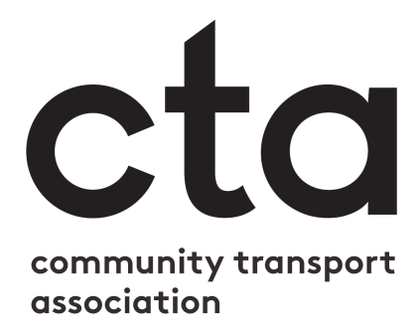

You can replace this box with your own logo, or delete it.

Risk Assessment [Your Organisation’s Name Here]

Template from the Community Transport Association
To do a risk assessment, you need to understand what, in your business, might cause harm to people and decide whether you are doing enough to prevent that harm. You can find more information on the risk assessment process in our ‘how to’ document at ctauk.org/advice-resources/risk-assessment-and-management. Once you have identified those hazards, you need to identify appropriate and sensible control measures and put them in place.

Start by:
- Identifying what can harm people in your workplace.
- Identifying who might be harmed and how.
- Evaluating the risks and deciding on the appropriate controls, taking into account the controls you already have in place.
- Recording your risk assessment.
- Reviewing and updating your assessment

A risk assessment is not about creating huge amounts of paperwork, but rather about identifying sensible measures to control the risks in your workplace. You are probably already taking steps to protect your employees, and your risk assessment will help you decide whether you have covered all you need to. Think about how accidents and ill health could happen and concentrate on real risks – those that are most likely and which will cause the most harm.

This template has been prepared to help you conduct a risk assessment in your organisation. For more help on completing the assessment, take a look at our Risk Assessment ‘how to’ guide and our COVID-19 risk assessment template at ctauk.org/advice-resources/risk-assessment-and-management.

Few workplaces stay the same. Sooner or later, you will bring in new equipment, substances and procedures that could lead to new hazards. Keep a regular schedule for reviewing your risk assessments (e.g. annually) and make sure to review and update them if you experience any major internal or external changes, e.g. COVID-19, new vehicle purchase, moving sites.

To fill in this template, you will need to remove all text in red, and replace any text in square brackets [].

This risk assessment for [insert organisation name] has been prepared to consider the specific hazards relating to our operations. It should be read in conjunction with our COVID-19 risk assessment document, and our Standard Operating Procedures. (This may have another name in your organisation, such as staff handbook).

This risk assessment will be reviewed every twelve months or following significant internal changes (e.g. change of Transport Manager, purchase of new vehicles, etc.).

Activity | What are the hazards? | Who might be harmed and how? | What are we already doing to manage risk? | What else can we do to reduce risk? | Responsible person | Action by when? | Date completed

Risk Assessment [Your Organisation’s Name Here]

Risk Assessment Completed by [Name] on [Date]
[Signature]

Review of Risk Assessment due by [Date]

