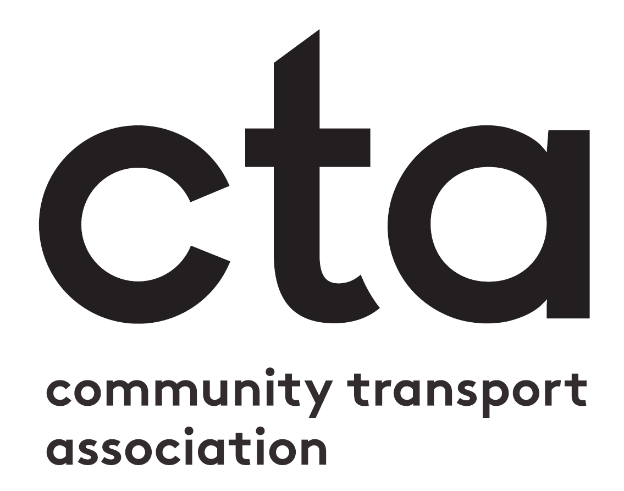

Nomination Form - Community Transport Provider of the Year
Before you fill in your nomination form
Have you read the Entry Requirements and Awards Criteria document? This has all the information you need to put together a good application. If you haven’t already download it, you can access it at ctauk.org/events/ctawards21. If you have any questions after reading the document, please don’t hesitate to get in touch with us via events@ctauk.org.
Filling in your nomination form
In this document, you can submit the written side of your application - which you then need to upload along with your supporting evidence to: surveymonkey.co.uk/r/ctawards21-nominate
This document has three sections:
- Background Information: the background information you need to supply is specified in the Rules of Entry and Criteria document. This does not count towards the word count of your main entry.
- Main Entry: this is the main body of your nomination. You can use up to 1,000 words which you can distribute as you see fit between the questions.
- Supporting Information Description: please give a short overview of the supporting information you will be uploading with this nomination form. This does not count towards your word limit.
When you have filled in this document, please upload it along with your supporting evidence to: surveymonkey.co.uk/r/ctawards21-nominate

Category: | Community Transport Provider of the Year
Nominee:
Background Information
Your submission should include a general profile of the organisation (up to 300 words) including:

- A description of the organisation including the work it does, who it supports and where it operates – both before and during the pandemic.

- An indication of the size of the organisation’s activities – number of passenger trips per year for example and/or the number of people and groups using their services including any numbers for COVID specific services or activities that might be mentioned in the main entry.

Main Entry
For the main body of the nomination you must answer the questions as laid out in the category’s criteria. The entry must be no more than 1,000 words but you can distribute the words across the questions as you see fit. The text boxes expand if you need them to.
How has the organisation adapted their services to meet the changing needs of their community during the coronavirus pandemic?
Your answer:

What impact has the organisation had on its local community and the lives and well-being of its passengers?
Your answer:

How does the organisation plan to build on what they’ve learned over the last year to deliver even better services for their communities in the future?
Your answer:

Supporting Evidence
- Please give a short overview of the supporting information you will be uploading with this nomination form. This does not count towards your word limit.
- For this category you can provide up to three supporting statements from passengers, partners or supporters of up to 300 words each, along with up to five images. These statements are often influential in the decision of the judging panel. You must provide at least two images.
- Please upload your supporting evidence at link surveymonkey.co.uk/r/ctawards21-nominate
This nomination includes the following as supporting evidence:

