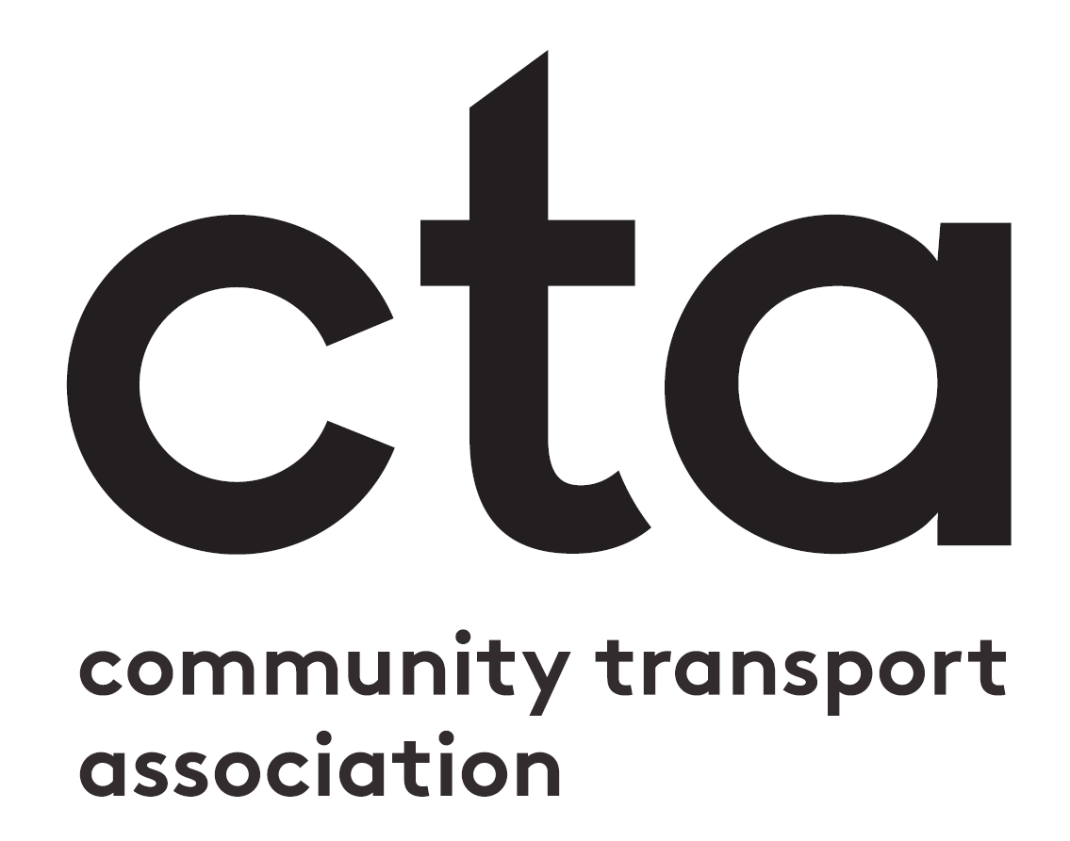

Nomination Form – Photo Competition
Before you fill in your nomination form
Have you read the Entry Requirements and Awards Criteria document? This has all the information you need to put together a good application. If you haven’t already download it, you can access it at ctauk.org/events/ctawards21. If you have any questions after reading the document, please don’t hesitate to get in touch with us via events@ctauk.org.
Filling in your nomination form
In this document, you can submit the written side of your application - which you then need to upload along with your photo at: surveymonkey.co.uk/r/ctawards21-nominate
This document has two sections
- Background Information: alongside your photo you should also provide a description (no more than 300 words) of who is in the photo and how you feel it encapsulates the spirit of community transport during the pandemic.
- Main Entry: a reminder of what we’re looking for in your photo entry.
When you have filled in this document, please upload it along with your photo to surveymonkey.co.uk/r/ctawards21-nominate

Category: | Photo Competition
Nominee:
Background Information
Please provide a description (no more than 300 words) of who is in the photo and how you feel it encapsulates the spirit of community transport during the pandemic.

Main Entry
A successful entry will follow the following format:

- A photo that encapsulates the spirit of community transport during the coronavirus pandemic.
- The focus should be on people, not just vehicles.
- The photo should be high quality and able to be shared in print and online.

You can upload this form and your photo at surveymonkey.co.uk/r/ctawards21-nominate

