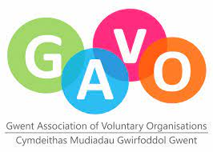
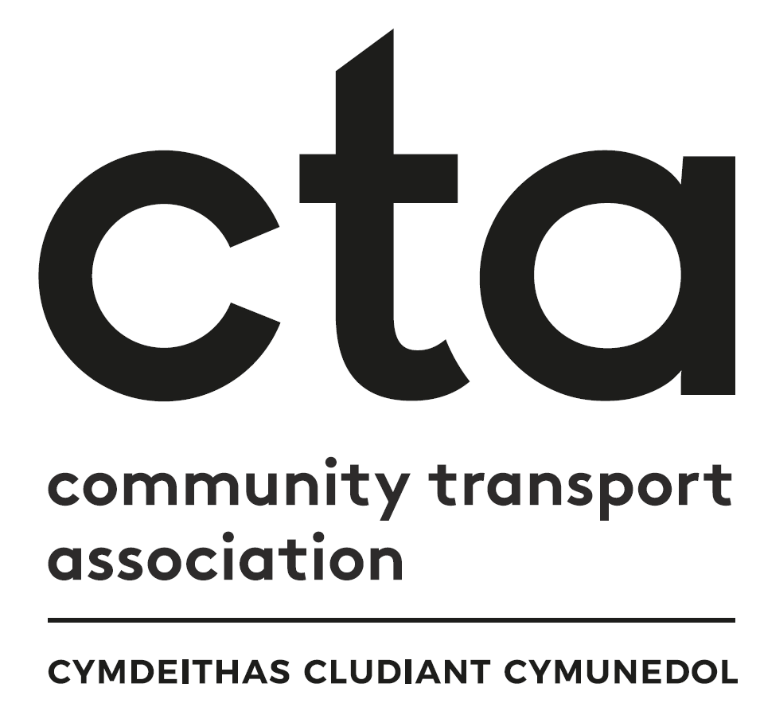

Transport to Health in Aneurin Bevan Continuation Grant Fund Application
‘Building on Year One’

Apply for up to £7,500

Introduction
Congratulations on being successful in your application for Transport to Health in Aneurin Bevan Grant Funding in 2021 – 22.

Transport to Health proved successful in its first year and has now secured a second year of funding to support more new projects, plus provision to provide continuation funding to first round successful applicants on a case-by-case basis, of up to £7,500.

If you have developed a successful not-for-profit transport service to support patients, visitors and staff across Caerphilly, Blaenau Gwent, Monmouthshire, Torfaen, Newport or South Powys to access health settings that you wish to continue to develop, we urge you to seek our support and apply again!

Applications for continuation funding will open in September 2022 and be reviewed by the grant panel on a rolling monthly basis up until the final award in March 2023. If all funding is allocated before this date, the application process will be closed.

If you have any queries, please contact the project’s Regional Community Transport Coordinator, Faye Mear on 07553 554083 or faye.mear@bridgescentre.org.uk

Part A: Evaluation

To apply for continuation funding for your project, we would first like to understand how your project has progressed to date and in relation to your initial application. Thinking about the plans you detailed in your initial application, please answer the following questions.
We would like honest and candid responses so we can understand how developing and running your project has been so far and appreciate your achievements and your difficulties equally.

Question 1 – What has worked well?

Please detail what has worked well when delivering your project. This could be something you had planned for or something unforeseen.

Your answer here (max 500 words)

Question 2 – What didn’t work so well?

Please detail what didn’t work so well when delivering your project. . This could be something you had planned for or something unforeseen.

Your answer here (max 500 words)

Question 3 – What have been the highlights from this project so far?

Please share case studies, stories and feedback that reflect things about your project that have been a success.

Your answer here (max 500 words)

Question 4 – What have been the challenges you have faced on this project so far?

Please share details of the difficulties you may have faced and give details of how you have met and resolved them. Equally, please include things that you have not been able to resolve, as yet.

Your answer here (max 500 words)

Part B: Continuation Proposal

Question 1 – What do you need to continue to take this project forward?

Please give details of what additional resources you need now.

This could be funding for capital or revenue expenditure. This can also include ongoing employment or volunteer support costs. Please also detail any no-cost items such as knowledge, support and advice you feel you need from the Coordinator or one of our Project Partner organisations.

Your answer here (max 500 words)

Question 2 – Why do you need this?

Please give the reasoning behind why you have identified the need for these additional resources.

Your answer here (max 500 words)

Question 3 – How will it aid your development and success into the future?

Please give a forecast of the impact and sustainability having these resources will have for your project.

These are aspirational. They could be how many new volunteers you want to recruit, how many more passengers you want to be able to accommodate, being able to increase the number of days you can offer your service, for example.

Your answer here (max 500 words)

Part C: Application Form - Governance

- FULL LEGAL NAME OF YOUR ORGANISATION (as per your governing document)

- FULL BUSINESS ADDRESS & POSTCODE
Phone Number (landline)
Mobile
Website Address
Organisation email

- TYPE OF ORGANISATION (Eg, Charity, CIC, Company Limited By Guarantee)
Organisation type
Charity Number
Company Number
Other

- DATE YOUR ORGANISATION WAS SET UP AS A LEGAL ENTITY

- VAT STATUS
Is your organisation VAT registered? | Yes/No
If registered please provide VAT Number

- Is your organisation independent or a branch/department of a larger organisation? If you are part of a larger organisation, please provide details:

- MAIN CONTACT
Please provide the main contact for this application. This is the person we will contact if further information is required and to inform you of the grant outcome.
Title
Forename(s)
Surname
Job Title or Position
Landline
Mobile
Email
- MONITORING & EVALUATION CONTACT
Your project will continue to be monitored and evaluated. If you are successful in your application for funding, we will require monthly monitoring forms to be completed and returned within 14 days of the end of each month (example forms included in the appendix). There will also be a broader evaluation form and interview at the end of your funding period. The Regional Community Transport Coordinator will stay in touch on at least a quarterly basis to support you and assist wherever they can.
If the lead individual responsible for this project’s monitoring and evaluation is different from the main contact named above, please provide their contact details.
Title
Forename(s)
Surname
Job Title or Position
Landline
Mobile
Email

- LEGALLY RESPONSIBLE CONTACT
Please provide a legally responsible contact for your application. This person cannot be the same person as the main contact and must be over 18 years of age. This person is responsible for ensuring the application is supported by the organisation applying, that the funded work is delivered, and that the organisation ensures CTA are appraised of progress.
Title
Forename(s)
Date of Birth
Position in the Organisation

- BANK ACCOUNT DETAILS
All organisations applying for a grant must have a bank or building society account in the name of the organisation as stated in your governing documents. Cheques must be signed by two people who are not related.
Bank Account name | Sort Code | Account Number

- FUNDING BREAKDOWN
Please outline details of any non-capital spend (i.e., revenue funding). Please include costs for everything you have detailed in Part A, Question 1.
Amount | Purpose of funding
e.g., £1000 | e.g., to create a fund to cover volunteer expenses for the new Saturday service for people visiting loved ones in GUH

- Please outline any items being purchased with expected costs (i.e., capital funding). If you intend to buy any item with a value of more than £5000, we will expect to see evidence of how you have ensured best value for money, eg, three quotations and please give a rationale for all your chosen suppliers.
Item spec | Cost Net | Cost Gross | Supplier details | Rationale for choosing selected supplier

- Do you have any match funding in place to support your application? If yes, please give details. Eg, grants from other sources (for instance National Lottery, Welsh Government etc), volunteer time given to the project etc.

- DECLARATION
We understand the criteria for this application and confirm that the information supplied in this application is accurate
 | Grant Applicant 1 | Grant Applicant 2
Signature

Name
Position / Title
Date

- Completed application forms must be sent to faye.mear@bridgescentre.org.uk by 1st October 2022 to be reviewed by the funding panel at their first meeting. Applications received after this date will be reviewed on a rolling monthly basis, until 1st March 2023, unless all funding is allocated prior to this date.

- The Project Partners strongly recommend organisations submit applications as early as possible. The funding will be allocated on a rolling monthly basis starting with applications received by 1st October 2022. The fund will either close when all monies have been allocated, or by the 31st March 2023.

- Please ensure any additional sheets are clearly marked with your organisation name.

- Please note that successful applicants may be asked to publicise and share the progress of the grant supported project with this project and with other organisations.

- If you have any further questions, please contact Faye Mear, Regional Community Transport Coordinator, on 07553 554083 or faye.mear@bridgescentre.org.uk.

