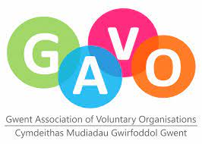
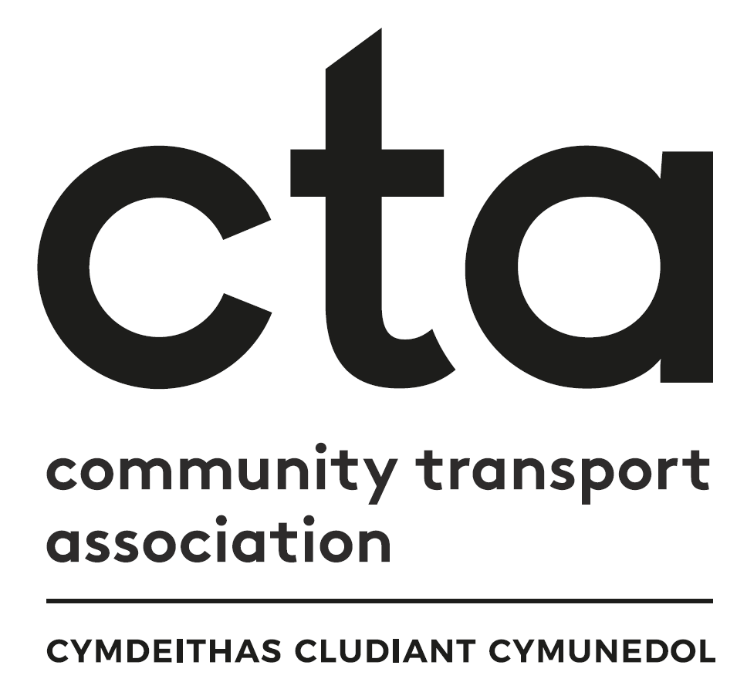

Transport to Health in Aneurin Bevan Grant Fund Application
‘Building on Year One’

Apply for up to £10,000

Introduction
This grant fund has been designed to support the growth and development of accessible and inclusive transport to health within the Aneurin Bevan University Health Board’s (ABUHB) footprint, covering Caerphilly, Blaenau Gwent, Monmouthshire, Torfaen, Newport and South Powys.

Following a period of research and consultation in 2021, the team at ABUHB, in partnership with the Community Transport Association (CTA), identified that there are significant transport barriers to residents wishing to access the new Grange University Hospital and other health care settings across the region, particularly for those with additional access/support needs.

Across the region, patients, visitors, and staff report long travel times, limited transport options and expensive routes for those without access to private transport, including transit times of more than two hours to some hospitals and taxi fares upwards of £60 for a return journey. Geographic ‘hotspots’ have also been identified where residents experience fragmented public transport provision and current community transport (CT) options are limited. Existing CT operators report that transport to health represents a significant percentage of their current service, and a great willingness to further support people to access health settings.

This grant fund has been created to enable community-based organisations to develop new transport services, enhance existing ones, and engage in new partnerships to improve travel connections and quality standards across the region. The first round of funding ran from July 2021 – March 2022 and supported eight community transport initiatives to launch or develop, but there is still more work to be done. In recognition of this ongoing need, ABUHB have provided further funding to be awarded from September 2022 until March 2023.

If you are looking to develop or grow a not-for-profit transport service to support patients, visitors or staff across Caerphilly, Blaenau Gwent, Monmouthshire, Torfaen, Newport, or south Powys to access health settings, we urge you to apply!

Applications will be reviewed by the grant panel on a rolling monthly basis up until the final award in March 2023. If all funding is allocated before this date, the application process will be closed. Organisations can apply for up to £10,000 and are permitted to submit multiple applications for separate projects up to this total value.

If you have any queries, please contact the project’s Regional Community Transport Coordinator, Faye Mear, on 07553 554083 or faye.mear@bridgescentre.org.uk

Grant Aims

To support and grow accessible and inclusive transport services that enable patients, visitors, and staff to access health settings across the ABUHB area.

To contribute to the development of a comprehensive integrated network of accessible transport to health care settings for people living in Caerphilly, Blaenau Gwent, Newport, Torfaen, Monmouthshire and south Powys.

Grant Priorities

The project’s partners have agreed the priorities below to inform how grants will be awarded. Applications will be reviewed against these priorities, and we expect applicants to demonstrate how their project will deliver on one or more of them. The two top priorities for this project are highlighted in bold.

What you need to do before making an application

- Check your organisation’s eligibility

Your organisation can apply if: | The fund will not support:
- It is a third/voluntary sector (not-for-profit) organisation and is independent of government, private and public sectors:  - Registered charity  - Constituted group  - Community Interest Company  - Charitable Incorporated Organisation  - Company limited by guarantee  - It is a private company committed to delivering not-for-profit transport services to support the community, alongside any commercial work (e.g., taxi firms)  - The proposed project will contribute to one or more of the fund’s aims and priority areas  - Your organisation has at least 2 authorised unrelated signatories  - Your organisation has its own bank account or an account in the name of the ‘Trustees of [name of organisation]’  - You are willing to take part in an independent evaluation of the impact of the grants  - The project must be initiated between 1st September 2022 and 31st March 2023 all funding must be spent within 12 month of initiation unless with prior agreement/consultation. Projects beginning on any other date will not be eligible.  - The proposed project has not been previously funded by Transport to Health (There is a different process for projects previously successful in being awarded Transport to Health funding who are interested in continuation funding) | - A political organisation  - A statutory organisation*  - An individual  *Please note, the funding panel will be happy to see bids submitted by partnerships which include statutory organisations, provided the lead partner is a not-for-profit organisation

- Have key documents ready to submit. These are as follows:

Documents to be submitted with application | Tick to Confirm | Documents to be made available on request | Tick to Confirm
Employer’s Liability Certificate |  | Equal Opportunities Policy
Public Liability Certificate |  | Environmental Policy
Bank Statement (last 3 months) |  | Volunteering Policy
Annual Accounts (last financial year) |  | Safeguarding Vulnerable Adults Policy
Governing Documents |  | Welsh Language Policy
 |  | Data Protection Policy

PART A: Application Form – Project Proposal

Question 1 – Describe The Project You Want Funding For

Please describe your planned project and what you want to do with the money.
We are looking for an overall description of the project that will help us to understand what you need the grant for, what the project will achieve, and how it will sit alongside or within your existing work.

What is/are this project’s aims? What activities will take place? What will the funding be used for?

Your answer here (max 500 words)

Question 2 – Demonstration of Need

Please explain how you know this project is needed.

How do you know this will complement and not duplicate activity in your area? Have you involved your community in developing and designing it? Please include details of any surveys, mapping, feasibility studies or pilot projects you may have conducted.

Your answer here (max 500 words)

Question 3 – Fit with grant’s Aims and Priorities

How does your project fit within the stated aims and priorities for this fund?

Please see the Grant Aims and Grant Priorities listed on Page 2 for reference

Your answer here (max 500 words)

Question 4 – Partnerships

Will your project involve any partnership working with other groups or organisations, such as existing transport providers, local groups and organisations or members of your community?

If yes, please give details including how they have been involved in co-developing the project.
Your answer here (max 500 words)

Question 5 – Impact

What actions will be taken to embed this project sustainably into your service in the longer term so it can continue after this funding has been spent?

This may be planning to charge for the services you offer to cover costs, applying for further grants from other sources etc

Your answer here (max 500 words)

Question 6 – Past Projects

(For existing organisations only. Answer will not be scored)

If you are already an established organisation, please give us an example of a previous project you have delivered (it does not have to be transport related).

Include details of when you delivered this work, how long it went on for and the outcomes

Your answer here (max 500 words)

Question 7 – Additional Information (Answer will not be scored)

Is there any other information you would like to provide in support of your application?

Include any background information regarding your organisation as a whole, other activities your organisation are involved in delivering, your wider aims and objectives, future aspirations etc

Your answer here (max 500 words)

Part B: Application Form - Governance
- FULL LEGAL NAME OF YOUR ORGANISATION (as per your governing document)

- FULL BUSINESS ADDRESS & POSTCODE
Phone Number (landline)
Mobile
Website Address
Organisation email

- TYPE OF ORGANISATION (Eg, Charity, CIC, Company Limited By Guarantee)
Organisation type
Charity Number
Company Number
Other

- DATE YOUR ORGANISATION WAS SET UP AS A LEGAL ENTITY

- VAT STATUS
Is your organisation VAT registered? | Yes/No
If registered please provide VAT Number

- Is your organisation independent or a branch/department of a larger organisation? If you are part of a larger organisation, please provide details:

- MAIN CONTACT
Please provide the main contact for this application. This is the person we will contact if further information is required and to inform you of the grant outcome.
Title
Forename(s)
Surname
Job Title or Position
Landline
Mobile
Email

- MONITORING & EVALUATION CONTACT
Your project will be monitored and evaluated. If you are successful in your application for funding, we require monthly monitoring forms to be completed and returned within 14 days of the end of each month (example forms included in the appendix). There will also be a broader evaluation form and interview at the end of your funding period. The Regional Community Transport Coordinator will stay in touch on at least a quarterly basis to support you and assist wherever they can.
If the lead individual responsible for this project’s monitoring and evaluation is different from the Main Contact named above, please provide their contact details.
Title
Forename(s)
Surname
Job Title or Position
Landline
Mobile
Email

- LEGALLY RESPONSIBLE CONTACT
Please provide a legally responsible contact for your application. This person cannot be the same person as the main contact and must be over 18 years of age. This person is responsible for ensuring the application is supported by the organisation applying, that the funded work is delivered, and that the organisation ensures CTA are appraised of progress.
Title
Forename(s)
Date of Birth
Position in the Organisation

- BANK ACCOUNT DETAILS
All organisations applying for a grant must have a bank or building society account in the name of the organisation as stated in your governing documents. Cheques must be signed by two people who are not related.
Bank Account name | Sort Code | Account Number

- FUNDING BREAKDOWN
Please outline details of any non-capital spend (i.e., revenue funding). Please include costs for everything you have detailed in Part A, Question 1.
Amount | Purpose of funding
e.g., £1000 | e.g., to create a fund to cover volunteer expenses for the new Saturday service for people visiting loved ones in GUH

- Please outline any items being purchased with expected costs (i.e., capital funding). If you intend to buy any item with a value of more than £5000, we will expect to see evidence of how you have ensured best value for money, eg, three quotations and please give a rationale for all your chosen suppliers.
Item spec | Cost Net | Cost Gross | Supplier details | Rationale for choosing selected supplier

- Do you have any match funding in place to support your application? If yes, please give details. Eg, grants from other sources (for instance National Lottery, Welsh Government etc), volunteer time given to the project etc.

- DECLARATION
We understand the criteria for this application and confirm that the information supplied in this application is accurate
 | Grant Applicant 1 | Grant Applicant 2
Signature

Name
Position / Title
Date

- Completed application forms must be sent to faye.mear@bridgescentre.org.uk by 1st October 2022 to be reviewed by the funding panel at their first meeting. Applications received after this date will be reviewed on a rolling monthly basis, until 1st March 2023, unless all funding is allocated prior to this date.

- The Project Partners strongly recommend organisations submit applications as early as possible. The funding will be allocated on a rolling monthly basis starting with applications received by 1st October 2022. The fund will either close when all monies have been allocated, or by the 31st March 2023.

- Please ensure any additional sheets are clearly marked with your organisation name.

- Please note that successful applicants may be asked to publicise and share the progress of the grant supported project with this project and with other organisations.

- If you have any further questions, please contact Faye Mear, Regional Community Transport Coordinator, on 07553 554083 or faye.mear@bridgescentre.org.uk.

