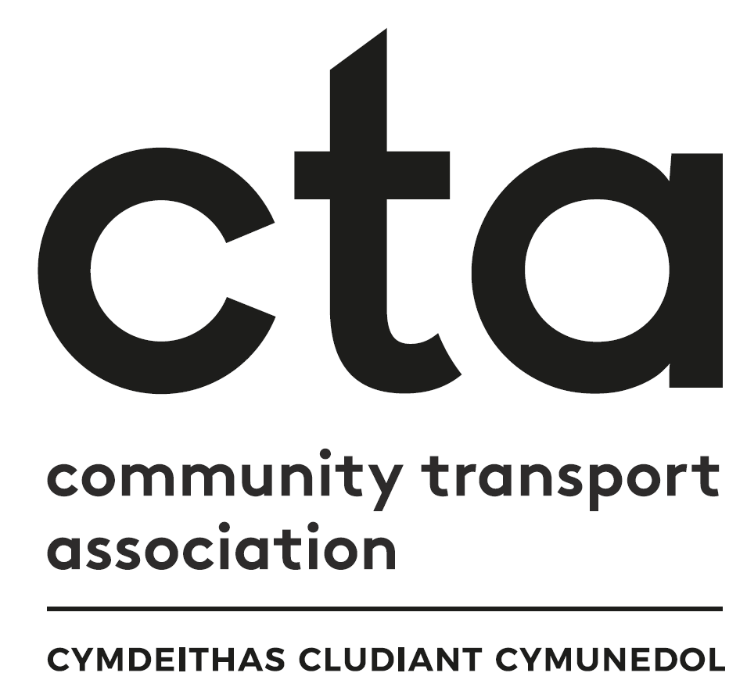
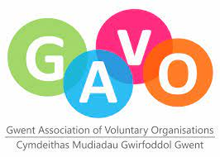
Transport to Health in Aneurin Bevan Continuation Grant Fund
Application Checklist

This checklist is for Applicants to use to ensure they have completed the form correctly and supplied all the evidence the panel will need to assess and score their bid.

If you have any queries before submitting your application please contact Faye Mear, Regional Community Transport Coordinator on 07553 554083 or faye.mear@bridgescentre.org.uk

Eligibility | YES?
Are you a third/voluntary sector (not-for-profit) organisation and is independent of government, private and public sectors:
Registered charity
Constituted group
Community Interest Company
Charitable Incorporated Organisation
Company limited by guarantee
OR are you a private company committed to delivering not-for-profit transport services to support the community, alongside any commercial work (e.g., taxi firms)?
Has the project previously been funded by Transport to Health grant?
Will the project contribute to one or more of the fund’s Aims and Priorities (Page 3)?
Does your organisation have at least 2 authorised unrelated signatories?
Does your organisation have its own bank account or an account in the name of the ‘Trustees of [name of organisation]’
Are you willing to take part in an independent evaluation of the impact of the grants?
Have you completed questions 1 - 4 in part A of the application form?
Have you completed questions 1 - 3 in part B of the application form?
Have you completed questions 1 – 13 in part C of the application form?

Eligibility | YES?
Have you included the mandatory documents?
- Employer’s Liability Certificate
- Public Liability Certificate
- Bank Statement (last 3 months)
- Annual Accounts (last financial year)
- Governing Documents
Have you supplied evidence of best value for any capital items costing £5,000 or more?
Have you supplied evidence of match funding (if this is applicable)?
Have you clearly marked any additional sheets with your organisation’s name?
Have both your authorised signatories signed the application form?

Congratulations, you are ready to submit your application!

Send your application and all associated documents to faye.mear@bridgescentre.org.uk

Grant Aims

To support and grow accessible and inclusive transport services that enable patients, visitors, and staff to access health settings across the ABUHB area.

To contribute to the development of a comprehensive integrated network of accessible transport to health care settings for people living in Caerphilly, Blaenau Gwent, Newport, Torfaen, Monmouthshire and south Powys.

Grant Priorities

The project’s partners have agreed a number of priorities to inform how grants will be awarded. Applications will be reviewed against these priorities, and we will expect applicants to demonstrate how their project will deliver one or more of them. The two top priorities are highlighted in bold.

