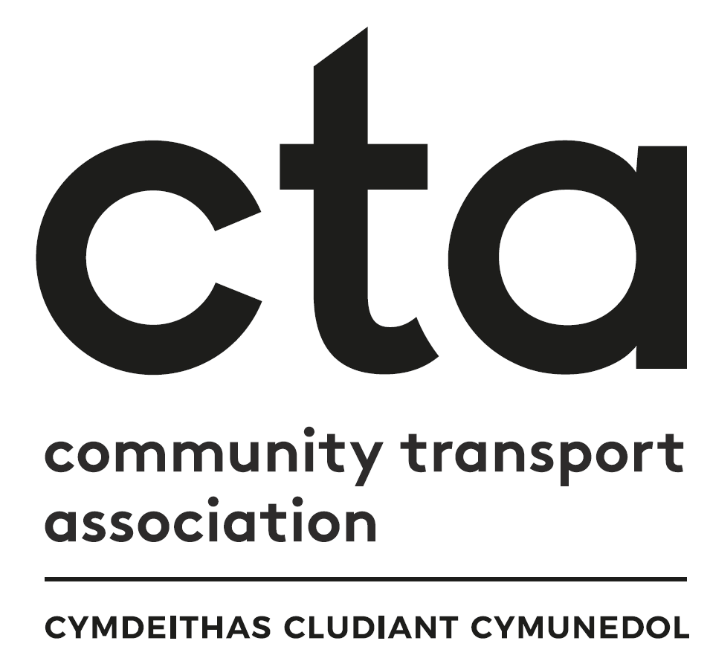

Transport to Health in Aneurin Bevan
Continuation Grant Fund Scoring Matrix

Thank you for your interest in the Aneurin Bevan Transport to Health Continuation Grant Fund.
This document will be used by the grant funding panel to assess all applications we receive. By sharing our scoring criteria with you, we hope that you will be able to see how to structure your application to give you the best possible chance of success. As you will see below, some questions are mandatory to ensure our governance is robust – we will only consider applications that meet the mandatory criteria. The other questions will be scored against the criteria listed below by each member of the funding panel, who will then meet virtually to agree a joint score for each application. This scorecard will be shared with you when the panel has made its decision.
Please do not hesitate to get in touch if you need any further information before submitting your application. You can reach Faye Mear, Regional Community Transport Coordinator on 07553 554083 or faye.mear@bridgescentre.org.uk

Mandatory Criteria

- Has the applicant fully completed parts A and B of their application form? Yes / No

- Has the applicant included the required documentation with their application?

Documents to be submitted with application | Tick to Confirm
Employer’s Liability Certificate
Public Liability Certificate
Bank statement (last 3 months)
Annual Accounts
Governing Documents

APPLICATIONS MUST PASS ALL THE MANDATORY CRITERIA TO BE CONSIDERED FOR SELECTION

Application Assessment

0 points: Insufficient information supplied
1-2 points: Barely addresses the question asked – limited information provided
3-4 points: Reasonable answer provided, not all elements covered
4-5 points: Question answered very well, provides detail and covers all or most elements

Part A: Evaluation

Question 1 – What has worked well?
Please detail what has worked well when delivering your project. This could be something you had planned for or something unforeseen.
Response | Tick | Score | Notes
Insufficient information supplied |  | 0
Barely addresses the question asked |  | 1
Reasonable answer |  | 2-3
Question answered very well |  | 4-5

Question 2 – What didn’t work so well?
Please detail what didn’t work so well when delivering your project. . This could be something you had planned for or something unforeseen.
Response | Tick | Score | Notes
Insufficient information supplied |  | 0
Barely addresses the question asked |  | 1
Reasonable answer |  | 2-3
Question answered very well |  | 4-5

Question 3 – What have been the highlights from this project so far?
Please share case studies, stories and feedback that reflect things about your project that have been a success.
Response | Tick | Score | Notes
Insufficient information supplied |  | 0
Barely addresses the question asked |  | 1
Reasonable answer |  | 2-3
Question answered very well |  | 4-5

Question 4 – What have been the challenges you have faced on this project so far?
Please share details of the difficulties you may have faced and give details of how you have met and resolved them. Equally, please include things that you have not been able to resolve, as yet.
If yes, please give details including how they have been involved in co-developing the project.
Response | Tick | Score | Notes
Insufficient information supplied |  | 0
Barely addresses the question asked |  | 1
Reasonable answer |  | 2-3
Question answered very well |  | 4-5

Part B: Continuation Proposal
Question 1 – What do you need to continue to take this project forward?
Please give details of what additional resources you need now.

This could be funding for capital or revenue expenditure. This can also include ongoing employment or volunteer support costs. Please also detail any no-cost items such as knowledge, support and advice you feel you need from the Coordinator or one of our Project Partner organisations.
Response | Tick | Score | Notes
Insufficient information supplied |  | 0
Barely addresses the question asked |  | 1
Reasonable answer |  | 2-3
Question answered very well |  | 4-5

Question 2 – Why do you need this?
Please give the reasoning behind why you have identified the need for these additional resources.
Response | Tick | Score | Notes
Insufficient information supplied |  | 0
Barely addresses the question asked |  | 1
Reasonable answer |  | 2-3
Question answered very well |  | 4-5

Question 3 – How will it aid your development and success into the future?
Please give a forecast of the impact and sustainability having these resources will have for your project.

These are aspirational. They could be how many new volunteers you want to recruit, how many more passengers you want to be able to accommodate, being able to increase the number of days you can offer your service, for example.
Response | Tick | Score | Notes
Insufficient information supplied |  | 0
Barely addresses the question asked |  | 1
Reasonable answer |  | 2-3
Question answered very well |  | 4-5
Grant Priorities

How many of these priorities will this application meet? | Demonstrated?  (delete as appropriate) | Points if demonstrated
Transport options that work for everyone | Yes / No | 2  (top priority)
An accessible and inclusive transport network across the health board's footprint | Yes / No | 1
Services that have been developed in partnership - with communities, passengers, or partners - to ensure they meet the widest possible needs | Yes / No | 1
Low carbon solutions that help us to deliver services in an environmentally sustainable way | Yes / No | 1
Services that are designed to be viable in the longer term, embedded in the communities they serve | Yes / No | 1
Connecting with other modes of transport to improve integration | Yes / No | 1
Supporting people across the region to connect with their local health services | Yes / No | 2  (top priority)
 | Total | /9

Governance
Compliance Criteria | Demonstrated?  (delete as appropriate) | Points if demonstrated
Has the applicant provided complete governance information in part C? | Yes / No | 2
Has the applicant demonstrated that this project represents good value for money? | Yes / No | 2
Has the applicant provided the required documents as set out in the application? | Yes / No | 2
 | Total | /6

FINAL TOTAL= / 50

Would you be prepared to fully fund this project? (delete as appropriate)
Yes / No / More information required

Are there any parts of this project you would not fund?
Yes / No
[Insert answer here explaining the rationale if yes]

