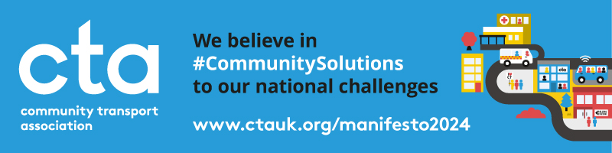

CTA Manifesto 2024: Letter to Candidates Template

CHECKLIST
- Confirm your local constituency
- Find your local candidates
- Amend our letter template
- Send to your local candidates
- Arrange a call, meeting or visit
GUIDE
The UK General Election 2024 is a massive opportunity to shape what the next UK Government does for Community Transport operators, staff, volunteers and passengers in the next 5 years.
CTA’s Manifesto – National Challenges, Community Solutions – calls for a new and dynamic partnership between the next UK Government, CTA and the Community Transport sector. And we're inviting all of our members to be part of our UK-wide campaign for change!
We need your help in constituencies across England, Scotland, Wales and Northern Ireland to reach out to and influence as many local candidates and parties as we can. We’ve created this letter template to help you write to or email your local candidates, which we hope you’ll adapt and use to reflect your community, your priorities and your services.
We don’t yet know for sure when polling day will be, but it must be held no later than 28 January 2025 and is expected in 2024. It could be as early as May or as late as November. Parties are already confirming who their local candidates will be.
So, now is the perfect time to start preparing for your local campaigning!
You can use these links to find some of your local candidates:
- Find your local constituency and current MP regardless of party
- Find your local Labour Party candidate
- Find your local Conservative and Unionist Party candidate
- Find your local Green Party candidate
- Find your local Liberal Democrat candidate
- Find your local Scottish National Party candidate (Scotland only)
- Find your local Reform Party candidate
- Find your local Plaid Cymru candidate (Wales only)
More than 83 MPs have announced that they’ll be standing down and there have been significant boundary changes for this election, so you make sure to contact candidates from all parties and none, as well as double-check whether your constituency has changed shape or name since we all last voted in 2019.
Volunteers for the website Who Can I Vote For? maintain a list of known and confirmed candidates and parties standing in every constituency at the next UK General Election, if you already know what yours is called. You can filter by nation, region or party. Some contact details are listed, where available.

TEMPLATE
[YOUR LOGO]
[DATE]
[NAME]
[ADDRESS]
RE: A MANIFESTO FOR COMMUNITY TRANSPORT – WILL YOU SUPPORT US?
Dear [NAME],
I am writing on behalf of [ORGANISATION] to you as the Prospective Parliamentary Candidate for [PARTY] in [CONSTITUENCY] for the next UK General Election.
[ORGANISATION] is a local charity/community group/social enterprise [DELETE AS APPROPRIATE] delivering community solutions to the national challenges of a shrinking bus network/an ageing population/the future of the NHS and social care/climate change/the cost-of-living crisis/levelling up [DELETE AS APPROPRIATE]. We are part of a thriving Community Transport movement across the UK, which is always for a social purpose and never for a profit.
Our services include a volunteer car scheme/dial-a-ride/car club/community bus/non-emergency patient transport/bike hire/prescription and shopping delivery [DELETE AS APPROPRIATE]. Every year/month/day we help [NUMBER OF USERS/PASSENGERS] people to access amenities/education/employment/hospital appointments/social care/public services/see friends and family [DELETE AS APPROPRIATE].
The work we do is essential to tackle exclusion, isolation and loneliness/reduce transport poverty and inequality/give disabled people freedom and independence/help older people live healthier, longer lives in their own homes/help young people get to college, university and work/reduce car dependency and carbon emissions [DELETE AS APPROPRIATE].
But for far too many people in [CONSTITUENCY], our transport system does not work for them. [ANY SPECIFIC LOCAL ISSUES OR CONTEXT?] The next UK Government must do more to ensure everyone has access to local transport which meets their needs.
We strongly support the Community Transport Association’s Manifesto for Community Transport for the next UK General Election, A Better Future for Transport: National Challenges, Community Solutions. You can read it here: www.ctauk.org/manifesto2024.
We join with CTA in calling for Modernising for Growth/Improving Access to Health and Social Care/Investing in Community Solutions/Accelerating Community-Led Climate Action/Delivering a Fair Deal for Volunteers [DELETE AS APPROPRIATE – WHICH IS YOUR MOST PRIORITY?] by [INSERT PRIORITY RECOMMENDATION – i.e. ‘granting D1 licence entitlements to B licence holders to tackle minibus driver shortages’ OR ‘working with and investing in Community Transport to design and deliver local sustainable transport solutions which harness the full potential of community-led climate action’]
We believe that this change would enable us to [EXPLAIN BENEFIT/IMPACT FOR YOUR SERVICES/PASSENGERS/COMMUNITIES].
We urge you and your party to consider this and all of the Manifesto’s recommendations. If you are elected by the people of [CONSTITUENCY], will you commit to working to implement it and to supporting Community Transport in the House of Commons?
We would like to meet with you to discuss this further and would be pleased to welcome you to our premises in [LOCATION] to learn more about what we do and see our services in action.
We look forward to hearing from you soon.
Yours sincerely,
[NAME]
[POSITION]
[SIGNATURE]

